Our Lady of Lourdes RC Primary School
Parent Calculation Booklet



Helping your Child with Calculation

Helping your Child with Calculation

Contents Page

Introduction Page 3

Development of known addition and subtraction facts Page 4

Addition
Reception Page 5
Year 1 Page 6
Year 2 Page 8
Development of written methods in Years 3, 4, 5 and 6 Page 10

Subtraction
Reception Page 13
Year 1 Page 14
Year 2 Page 16
Development of written methods in Years 3, 4, 5 and 6 Page 18

Development of times tables Page 21

Multiplication
Reception Page 22
Year 1 Page 23
Year 2 Page 23
Development of written methods in Years 3, 4, 5 and 6 Page 26

Division
Reception Page 31
Year 1 Page 32
Year 2 Page 35
Development of written methods in Years 3, 4, 5 and 6 Page 36
Glossary Page 40

Our aim is that every child will leave Our Lady of Lourdes Catholic Primary School with an efficient strategy for addition, subtraction, multiplication and division that is built on mathematical understanding.

This booklet aims to support parents to help their children with mathematics whilst they are at Our Lady of Lourdes Catholic Primary School. Calculation builds upon early number work that is developed in Reception, Year 1 and Year 2 and is dependent on children having a good understanding of the number system e.g.
- Locating and ordering numbers
- Counting in different size steps
- Know and use number facts

All children will progress through written calculation strategies which is why we have not attached Year Groups to each method. You will be informed by your child’s teacher of the methods they will be using on a regular basis through the termly topic letter and regular Parent Consultation Meetings.

We recognise that not every child will be able to use the standard written methods, but we hope they will have an efficient method that they can use to succeed to calculate.

For all calculations, children will be encouraged to use mental strategies as their first port of call and will only use a written method or calculator if the calculation is too difficult to do mentally or with a jotting.

Children are encouraged to think:
‘Can I do it …
- Mentally in my head
- Mentally with a jotting
- Using concrete resources
- Using a written method

For all operations, at each stage we extend children through application in different contexts rather than using bigger numbers. It is not a race to get to the final stage of calculation but much more beneficial to be able to apply skills efficiently!

Definitions:
Written Method – Standard algorithms, there tends to be only one standard method for each operation e.g. decomposition / vertical methods.
Expanded Methods – ‘Stepping stones’ to support the development of standard written methods.
Development of Known Addition and Subtraction facts

A good knowledge and quick recall of addition and subtraction facts is essential to children’s mathematical progress. In Our Lady of Lourdes the children are taught the 25 key facts in order to work out any other addition and subtraction fact.

Stage 1 |  |  |  | Stage 2 | Stage 3
Facts for All numbers to 5 |  |  |  | All bonds of 10 | Facts for All numbers to 9
2 | 3 | 4 | 5 | 10 | 6 | 7 | 8 | 9
1 + 1 | 2+1 | 3+1  2+2 | 4+1  3+2 | 9+1  8+2  7+3  6+4  5+5 | 5+1  4+2  3+3 | 6+1  5+2  4+3 | 7+1  6+2  5+3  4+4 | 8+1  7+2  6+3  5+4

Step 1 | Can partition a set of objects into 2 groups. | E.g. Can separate out 5 cubes into 4 and 1, 3 and 2 or cut up a number line into 4 and 1, 3 and 2
Step 2  3 for free | Can use and apply the commutative rule in addition. | E.g. Can use knowledge of 3 +2 = 5 to know 2+3 also = 5.
Step 2  3 for free | Can use and apply the inverse rule. | E.g. Can use Knowledge of 7+3 = 10 to know/work out 10-3=7 and 10-7=3.
Step 3  Finding al the relatives | Can deduce from a known fact to work out an unknown fact. | E.g. if know 4 +4=8 can work out 4+5=9.
Step 3  Finding al the relatives | Can derive and combine fact knowledge to work out any addition and subtraction facts. | E.g. If know  6 + 4 = 10 then  16 + 4 = 20  60 + 40= 100  0.06 + 0.04= 0.1  Etc etc

The ability to use and apply these number facts will enable children to calculate efficiently.
ADDITION

In Reception, children begin to become aware of addition in a practical context.

They will:
- Combine sets of objects and count all to find the total.
- Find one more than numbers up to 10.
- Develop understanding of vocabulary (how many altogether?)
- Begin to relate adding to counting on.
- Add a one digit to a one digit number.
- Draw pictures to develop their recording
- Be encouraged to develop a mental picture of the number system in their heads to use for calculations.
- Use number songs and rhymes
- Count sets of objects and understand they quantity related to each number e.g. the ‘fiveness’ of five being consistent as 5 counters / 5 fingers / 5 dots on a dice / 5 windows / 5 children etc.
- Use practical objects.

Problem Solving is developed through real life situations: Roles play areas. E.g.
There are 2 children in the home corner, 2 more go in, how many now?

Please talk to your child about numbers in everyday situations e.g. house numbers, bus numbers, how many windows? how many wheels? etc…

In Year 1 the children continue to take a practical approach to addition. They learn that addition is combining two sets of numbers. They can use their fingers, cubes, counters, bead strings and practical objects to help them. Children use different representations to help with their addition skills: Part-whole model, Bar model, Ten frames and Number shapes.

The children also use number lines to solve addition calculations by counting on.
3 + 2 = 5
+1
+1

___________________________________________
0 1 2 3 4 5 6 7 8 9

The children learn the different vocabulary involved in addition such as add, plus, total, altogether and equals.

The children learn to record addition in a number sentence, understanding the meaning of the + sign and =.
They add one digit and two digit calculations e.g. 3+4, 12+6.
They also add one and two digit numbers to multiples of 10 e.g. 20+5, 30+17.

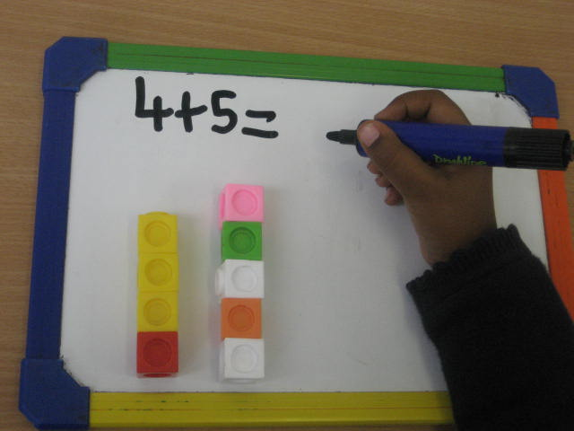

The children then move on to finding the missing numbers in number sentences using symbols, e.g.

2 + 3 =

+ = 5

The children begin to understand place value. They learn that 11 is made up of 1 ten and 1 unit, 15 is made up of 1 ten and 5 units, etc.
The children will know all the possible ways to make 5 and begin to know all the ways to make 10. This is known as number bonds.

In Year 2 the children continue to develop an understanding of addition as combining sets of numbers and counting on in steps along a number line.

They develop their understanding of place value using bead strings and other practical apparatus to show tens and units such as Part-whole model, Ten frames and Bar model.

The children are expected to recall addition facts asked in different ways such as ’27 add 10’, ‘add 26 to 30’ and ‘4 plus 8’

They develop their calculations to include 2 digit + 2 digit numbers e.g. 34+23.

First counting on in tens and ones.

34 + 23 = 57
+1
+1
+1
+10
+10

34 44 54 55 56 57

Then helping children to become more efficient by jumping in a multiple of 10 and adding the units in one jump (by using the known fact 4 + 3 = 7).
+20
+3
34 + 23 = 57

34 44 54 57

Children are encouraged to count on in jumps from the biggest number.

The children will understand that addition can be done in any order
15+12 is the same as 12+15

The children move away from solving addition sums practically and are expected to work mentally to complete written questions such as 2+7+4 and 1 + ? + 5 = 17. They are then asked to explain how they worked out their answer.

Development of written methods in Years 3, 4, 5 and 6 for Addition

As discussed in the introduction, pupils will progress through the stages at different rates. Your child’s class teacher will inform you of the methods being taught and used.

In order to be able to develop written methods, children need to be able to:
- Partition numbers into tens and units
- add multiples of 10
- know all addition facts up to 20 and to be able to apply them to multiples of 10 e.g. if I know 3+6=9 I also know 30+60=90 and 3+26=29 etc.

At every stage of addition development we teach and practise examples using the following progression.
- not crossing any boundary e.g. 112 +256
- crossing 10s only e.g. 117 + 256
- crossing 100s only e.g. 192 + 256
- crossing both e.g. 197 + 256

Stage 1 – The Expanded Vertical Method (starting with the largest value digit)

- This method should only be used for questions that they cannot do mentally. TU+TU, should be done MENTALLY with a number line jotting.
- An important point is that children should be able to describe what they are doing by referring to the actual values of the digits in the columns i.e. ’20 + 50’ or ‘2 tens + 5 tens’, never ‘2 + 5’.

Adding the most significant digits first.

247
+ 176
300 (200 + 100)
110 (40 +70)
13 (7+6)
423 = 423

Stage 2 – The Expanded Vertical Method (starting with the lowest value digit)

- This method should only be used for questions that they cannot do mentally. TU+TU, should be done MENTALLY with a number line jotting.
- An important point is that children should be able to describe what they are doing by referring to the actual values of the digits in the columns i.e. ’20 + 50’ or ‘2 tens + 5 tens’, never ‘2 + 5’.

Adding the least significant digits first.

247
+ 176
13 (7+6)
110 (40 +70)
300 (200 + 100)
423 = 423

Why most significant digit first and then least significant digit first?
When partitioning or calculating mentally we start with the most significant digit first (e.g. add the tens then add the units). This corresponds to Stage 1. However, in the compact vertical method we start by adding the least significant digit first. Stage 2 bridges the gap between these two stages (many children will only need to see it a few times to understand the relationship but others may need more experience at each stage).

Stage 3: Standard Written Method – Compact efficient form

- This is a conventional compact, efficient method, with carrying below the line.
- It is introduced by linking it directly to the expanded method, starting with the units.
- Children should be able to explain the link and appreciate that the compact method saves time recording their working.
- If, with a little practice, they cannot use the compact method without making errors, children will be encouraged to return to the expanded format
- Again, when describing each step, children should refer to the actual values of the digits.
247
+ 176
423
1 1 = 423

This strategy should not be taught to any child if they are insecure in their knowledge of place value and are not confident when using the previously mentioned strategies. We would appreciate it if you do not teach your child this method at home until we begin to teach it as the children often get confused when it comes to learning it at school as they do not fully understand why they are carrying numbers.
SUBTRACTION

In Reception, children begin to relate subtraction to taking away and counting how many are left.

They will:
- Take away some objects from a counted group and count how many are left
- Count up to find the difference e.g. between two towers of bricks.
- Find 1 less than a given number.
- Develop understanding of appropriate vocabulary: take away, less etc.
- Remove a smaller number from a larger and find how many are left by counting back from the larger number: E.g. We made 6 mince pies. We ate 2 of them, how many pies are left? Count back 2 from 6: 5, 4.
- Say together: 6 take away 2 is 4.
- Begin to count back on a number line.
- Introduce formal notation. — =
- Lots of practice using numbers up to 5, counting forwards and backwards.
- Singing number songs e.g., 5 Little Ducks went Swimming.
- Use a range of practical apparatus.

Problem Solving is practised in everyday life in the classroom, or in role play. Children make decisions about what to do. They explain orally and where appropriate, record the solution in their own way e.g. using pictures.

Please talk to your child about subtracting numbers in everyday situations e.g. how many people left at the bus stop? How many pieces of fruit left once some have been eaten?


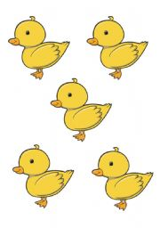

In Year 1, subtraction is taught through practical activities such as physically removing items from a set of objects, using fingers, using a bead string, counting on and back using a number line, using a Ten frame, Bar models and Part-Whole models. Children are expected to begin to understand subtraction as ‘taking away’ and ‘finding the difference’

Taking Away (counting back)
I have 6 apples and eat 3, how many are left?
6 – 3 = 3

___________________________________
0 1 2 3 4 5 6 7 8 9 10

Finding the Difference (counting on)
I have two pieces of ribbon. One is 6m long and the other is 3m long. What is the difference between them? 6-3 = 3

0 6

0 3

0 1 2 3 4 5 6

This ensures the children securely understand the concept and the vocabulary involved. Children are taught to be able to subtract a single digit from 10 and then 20. This coincides with learning number bonds and to 5 and then 10 by heart, as well as learning subtraction is the inverse of addition, (the opposite).

Examples will include:
- One digit – one digit e.g. 8-2=
- Two digit – one digit e.g. 26–3=
- Two digit – a multiple of 10 e.g. 36–20=

Subtraction will be linked to real life problems in money and role play. E.g Gabriel went to the shop with 10p, he brought a cake for 5p, how much change did he receive?

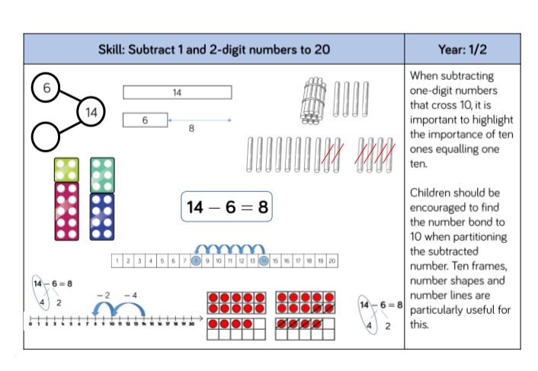
In Year 2, subtraction builds on the practical experience the children have gained in Year 1. Children are taught continue to use taking away and finding the difference to solve subtraction questions and begin to choose when which method is most appropriate. If the difference is large then counting back is more efficient e.g. 54-6, but if there is a small difference then counting on would be more appropriate e.g. 34-25. Children develop strategies to count on and back on a number line using two digit numbers.

Counting Back
First counting back in tens and ones.
47 – 23 = 24
- 10
- 10
-1
-1
-1
24 25 26 27 37 47

Then helping children to become more efficient by subtracting the multiples of ten and then the units in one jump (by using the known fact 7 – 4 = 3).
47 – 23 = 24
-20
23 27 47
-4

Counting On
First counting on in tens and ones.
47 – 23 = 24

+1
+1
+10
+1
+10
+1

(10+10+1+1+1+1)
23 33 43 44 45 46 47

Then helping children to become more efficient by subtracting the multiples of ten and then the units in one jump (by using the known fact 7 – 3 = 4).
47 – 23 = 24
+20
+4

(20+4)
23 43 47

Children need to understand that the answer comes from a different place depending on whether you are counting back or on. When counting back the answer is the number you land on. When counting on the answer is the total of the jumps that you have made.
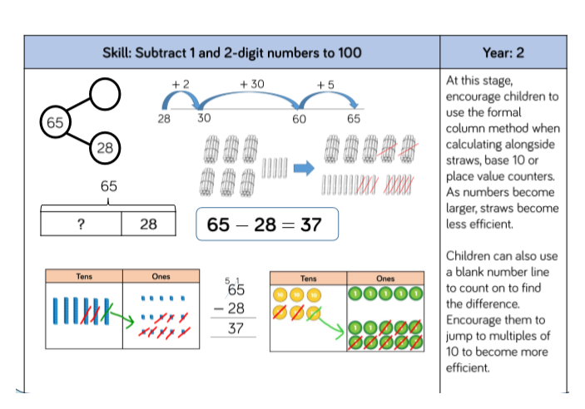
Development of written methods in Years 3, 4, 5 and 6 for Subtraction

As discussed in the introduction, pupils will progress through the stages at different rates. Your child’s class teacher will inform you of the methods being taught and used.

In order to be able to develop written methods, children need to be able to:
- Rapid recall of all pairs of numbers with a total of 10 and 100
- Counting on in steps of 10/100 etc
- Rounding to the next nearest multiple of 10.

At Our Lady of Lourdes we continue to use the number line for subtraction throughout Years 3, 4, 5 and 6 as it can be used for any subtraction question. When dealing with larger numbers (three digits and decimals) we teach children to count up although we recognise that some children will still count back as their preferred method.

Stage 1: Counting On
+26
+100
+20
+2
E.g. 326 - 178

0 178 180 200 300 326

100 + 26 + 20 + 2 = 148
You can reduce the number of stages further, by using knowledge of pairs of numbers that total 100.
+22
+126

178 200 326
126 + 22 = 148
+0.4
+4
+0.2
Extend to bigger numbers and decimals.
E.g. 22.4 – 17.8

17.8 18 22 22.4
4 + 0.4 + 0.2 = 4.6

Stage 1: Counting Back

Yr4 – subtract mentally TU-TU
Written methods for HTU-TU, HTU-HTU, £U.th-£U.th

Yr5 – subtract mentally whole number calculations. Subtract a near multiple of 1000 from another using counting up.
Written method for subtraction of 2 integers and decimals with 2dp e.g. 54.34-29.78

Yr6 – subtract mentally U.t-U.t
Written method for subtraction of 2 integers and decimals

E.g. 326 - 178
-2
-6
148
150
156
206
226
326
-100
-20
-50

326 – 178 = 148

Children can reduce the number of stages further, by using knowledge of pairs of numbers that total 100 and extend to bigger numbers and decimals.

SUBTRACTION: Decomposition

In Our Lady of Lourdes we acknowledge decomposition as the most commonly recognised standard written method for subtraction. However, we also recognise that decomposition does not link to any mental methods developed in Key Stage 1 and causes difficulties for many children.

As our primary aim is to ensure a solid understanding of the subtraction processes and not a race to get to the final written algorithm we only teach this method if and when a child is completely secure with using mental methods (e.g. a number line) to complete subtraction calculations.

Yr1 – understand subtraction as ‘take away’ and find a ‘difference’ by counting up. U-U, TU-U, TU-multiple of 10.

Yr2 - mentally TU-U, mentally with informal jottings TU-TU

Yr3 – subtract mentally U-U, TU-U, TU-TU
Written methods for HTU-TU, HTU-HTU

- If this time does arise and if, with a little practice, they cannot use the compact method without making errors, they should return to the expanded format or to a number line.
- Again, when describing each step, children should refer to the actual values of the digits.

Prerequisite skills:
Children need to have a good understanding of how to partition and repartition numbers.

E.g. 63 = 60 + 3
= 50 + 13 (by making the tens 10 less
and the units 10 more)

Stages 1, 2 and 3: Expanded vertical method
- The expanded vertical method of decomposition involves partitioning and recombining.
- The subtraction calculation is carried out in columns, starting with the least significant digits (the units).
Stage 2

E.g. 342 – 126
(300+40+2 – 100+20+6)

30 12
300 40 2
- 100 20 6
200 10 6 = 216

Stage 1

E.g. 263 – 141
(200+60+3 – 100+40+1)

200 60 3
- 100 40 1
100 20 2 = 122
leading to ‘repartitioning’ tens to subtract larger numbers of units from smaller ones

progressing through the
stages of repartitioning, until repartitioning tens and hundreds
Stage 3

725 – 367

110
600 10 15
700 20 5
- 300 60 7
300 50 8 = 358

Stage 4: Standard compact method of decomposition

Yr3 –
Written methods for HTU-TU, HTU-HTU

Yr4 –
Written methods for HTU-TU, HTU-HTU, £U.th-£U.th

Yr5 –
Written method for subtraction of 2 integers and decimals with 2dp e.g. 54.34-29.78

Yr6 –
Written method for subtraction of 2 integers and decimals

- A conventional compact, efficient method, is introduced by linking it directly to the expanded method, starting with the units.
- Children should be able to explain the link and appreciate that the compact method saves time recording their working.
- If, with a little practice, they cannot use the compact method without making errors, they should return to the expanded format or a number line.
- *Again, when describing each step, children should refer to the actual values of the digits.
Stage 4
E.g. 725 – 367

⁶7¹¹2 ¹5
- 3 6 7
3 5 8 = 358

Development of Times Tables

A good knowledge and quick recall of times tables is essential to children’s mathematical progress. In Our Lady of Lourdes the children are taught up to 12 x 12 with the target for all children being to know their tables by the end of Year Four. It is very important that children practice their times tables daily at home to enable this.

When learning their tables, children are taught to look for patterns such as odd and even number answers, or patterns made by adding together the separate digits in the answers.

Children are also taught to recognise the reversible effect so that they know 6 x 2 is the same as 2 x 6. They are also taught the relationship with division so that knowing 6 x 2 = 12 means they also know that 12 ÷ 2 = 6 and 12 ÷ 6 = 2. For each known times table fact, they also know three others:
6 x 7 = 42 so they know that 7 x 6 = 42
42 ÷ 6 = 7
42 ÷ 7 = 6

To help children with their multiplication, one of the ways we use is to find all the factors that are used to make up a number. For example the factors of 18 are 1,18, 2, 9, 6, 3 because 18 x 1, 1 x 18, 3 x 6, 6 x 3, 9 x 2, 2 x 9 all equal 18.
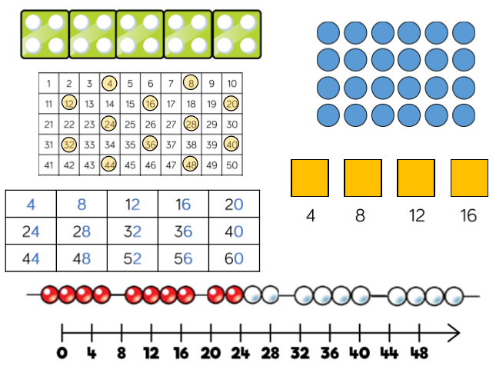
MULTIPLICATION

In Reception, children will experience equal sets or groups of objects and will begin to develop familiarity with counting in multiples of 2 and 10.

They will:
- Count pairs of socks, pairs of children, animals etc.
- Count on in twos and tens from any given number with modeling on a counting stick.
- Begin to recognise doubles (large dice, dominoes etc.).
- Develop understanding of appropriate vocabulary: double.
- Reinforce counting forward in 1’s from any number using a number line or number track.
- Singing number songs and number rhymes.
- Use a range of practical apparatus.

Problem Solving is practised in everyday life in the classroom, or in role play. Children make decisions about what to do. They explain orally and where appropriate, record the solution in their own way e.g. using pictures.

Please talk to your child about doubling numbers in everyday situations e.g. how many wheels are needed for 3 Lego cars? How many pieces of fruit are needed for 4 children?

In Year 1, children will continue to take a practical approach to multiplication. Through their experiences they will work with equal groups of objects. They are taught that when you double you add the same number to the original number or make it 2 times bigger. This learning can later be linked to work on the two times tables.

They also learn to count in 2s, 5s and 10s. This is taught using a mixture of number tracks, 100 squares, counting sticks, bead strings and real objects such as coins or beads. Counting real objects like beads in 2s, 5s and 10s helps children to understand that larger numbers are made up of lots or groups of smaller numbers. For example, if a child counts eight beads in 2s they can see that there are four lots of 2 in eight.

Calculations are put into practical contexts so that the child sees the relevance of the method they are learning. Children are encouraged to draw a picture as a helpful way to visualise a problem.

2 x 3 =
Each child has two eyes. How many eyes do three children have?

2 + 2 + 2 = 6

In Year 2, multiplication builds on the practical experience the children have gained in Year 1.

They are introduced to the sign for multiplication ‘x’ and the related vocabulary such as times and lots of.

Children use jottings to develop their understanding of multiplication calculation:

Repeated Addition
Children are taught that multiplication is repeated addition, this is modelled on empty number lines and/or using bead strings.

Q. There are five cakes in a pack. How many cakes are in three packs?
To find an answer to this, children need to count on in 5s from 0 until they have counted 3 lots of 5. The number line shows this process very clearly and helps them to keep track of what they have counted

3 times 5 is 5 + 5 + 5 = 15 or 3 lots of 5 or 5 x 3

5 x 3 = 5 + 5 + 5
5 5 5

0 1 2 3 4 5 6 7 8 9 10 11 12 13 14 15

Bead bars and bead strings are also used to model this:

5 x 3 = 5 + 5 + 5

5 5 5

Arrays

Children are also taught to model a multiplication calculation using an array. In arrays numbers are represented by dots. This knowledge will support with the development of the grid method. For example, 3 x 5 can be shown as

5 x 3 = 15

3 x 5 = 15

Arrays help demonstrate commutativity, i.e, children can see that multiplication can be done in any order. Children should know that 3 x 5 has the same answer as 5 x 3. This can also be shown on the number line.

5
5
5

0 1 2 3 4 5 6 7 8 9 10 11 12 13 14 15

3
3
3
3
3

Development of written methods in Years 3, 4, 5 and 6 for Multiplication

As discussed in the introduction, pupils will progress through the stages at different rates. Your child’s class teacher will inform you of the methods being taught and used.

In order to be able to develop written methods, children need to be proficient in the following skills:
- Partitioning
- Doubling and halving / Multiplying by 10
- Multiplication facts / calculation strategies
- Understanding multiplication as an array (this links to the grid method)

Stage 1: Mental method, using partitioning:
23 x 4

Step 1
First we partition the two-digit number into tens and units
23 = 20 + 3
Step 2
We remind the children that the calculation is 23 x 4, however we are going to break this down into smaller steps by partitioning it into 20 x 4 and 3 x 4. The brackets are used to tell the children that they must multiply the digits inside the brackets first, before they add them together. 23 x 4 = (20 x 4) + ( 3 x 4 )
Step 3
They then multiply the numbers inside the brackets. They will calculate 20 x 4 by either multiplying 2 by 4 and then multiply the answer by ten to get eighty, or by multiplying four by ten and then doubling the answer to get eighty. The children are encouraged to use a range of mental strategies to support them.
23 x 4 = 80 + 12
Step 4
Finally the children are reminded that although we have calculated 20 x 4 and 3 x 4 we need to add both the answers together to reach the final answer to 23 x 4. We add the ten from twelve to eighty to make ninety and then add the two.
23 x 4 = 92

The children set out the whole calculation the following way:
23 x 4 = ( 20 x 4 ) + ( 3 x 4)
= 80 + 12
= 92

Stage 2: Grid method:
- The mental method from which written methods are developed involves partitioning, and then multiplying the tens and ones separately.
- It is common to start with the tens when working mentally.
- A useful way of recording intermediate steps is the ‘grid’ method.
- This relates to finding the area of a rectangle.

TU x U 23 x 8
Children will approximate first – 23 x 8 is approximately 25 x 8 = 200

X | 20 | 3
8 | (20 x 8)  160 | (3 x 8)  24
23 x 8 = 160 + 24 = 184

Extend to bigger numbers
HTU x U 346 x 9
Children will approximate first – 346 x 9 is approximately 350 x 10 = 3500

X | 300 | 40 | 9
8 | (300 x 8)  2700 | (40 x 8)  360 | (9 x 8)  54
2700 + 360 + 54 = 3114

Stage 3: Extend further to TU x TU
72 x 38 Children will approximate first – 72 x 38 is approximately 70 x 40 = 2800
72 x 38 = (70 + 2) x (30 + 8)

X | 70 | 2
30 | (70 x 30)  2100 | (2 x 30)  60
8 | (70 x 8)  560 | (2 x 8)  16
2100 + 560 + 60 + 16 = 2736

Using similar methods, they will be able to multiply decimals with one decimal place by a single digit number, approximating first. They should know that the decimal points line up under each other.

e.g. 23.5 x 12
Children will need to approximate first – 25 x 10 = 250
23.5 x 12 = (20 + 3 + 0.5) x (10 +2)

X | 20 | 3 | 0.5
10 | (20 x 10)  200 | (3 x 10)  30 | (0.5 x 10)  5
2 | (20 x 2)  40 | (3 x 2)  6 | (0.5 x 2)  1

200+40+30+6+5+1 = 282

Vertical Format for Multiplication
- In Our Lady of Lourdes we acknowledge the vertical format as a standard written method for multiplication. However, as our primary aim is to ensure a solid understanding of the multiplication processes and not a race to get to the final written algorithm, we only teach this method if and when a child is completely secure with the previous stages. As a result the appropriate conditions for teaching this step may not arise during a child’s time at Our Lady of Lourdes.
- Some children may be introduced to a vertical format. They should first practise this with calculations they can do mentally.
- They can also investigate starting with the ones first rather than the tens. Children should describe what they do by referring to the actual values of the digits in the columns.
- The method is then extended to multiplying by two-digit numbers.

Stage 4: Vertical format, expanded working

38 x 7  38  X 7  210 (30x7= 210)  56 ( 8x7= 56)  266  = 266 | link to the grid method:  210 + 56 = 266
  X | 30 | 8
  7 | 210 | 56
56 x 27  56  X 27  1000 (50 x 20 = 1000)  120 ( 6 x 20 = 120)  350 ( 50 x 7 = 350)  42 ( 6 x 7 = 42)  1512 | link to the grid method:  1000 + 350 + 120 + 42 = 1512
  X | 50 | 6
  20 | 1000 | 120
  7 | 350 | 42

Stage 5: Vertical format, compact working

Yr5 – mentally multiply TUxU and mentally x25. Multiply whole numbers and decimals by 10, 100 and 1000. Written methods to multiply HTUxU, TUxTU, U.txU
Yr6 – mentally calculate TUxU, U.tXU. Written methods to TUxTU, HTUxTU
- The method is made more compact by combining steps.
- If after practice, children cannot use the compact method without making errors, they should return to the expanded format.

7 multiplied by 8 is 56, put 6 in the units column of the answer line and carry 50 into the tens’ column (5 tens) We do this because there might be some more tens. 7 multiplied by 30 is 210. I need to add the 10 to the 5 tens to make 60. I can put ‘6’ in the tens column. I then have 200 to put into the hundreds column.
38
X 7
266
5

56
20x6=120 (put the 20 in the answer line, carry the 100) 20x50=1000 (+the carried 100)=1120 in the answer line.
7x6=42 (put 2 in the answer line and carry the 40) 7x50=350 (+the carried 40) = 392 in the answer line
1120 + 392 = 1512

x 27
1120 (56 x 20)
392 (56 x 7)
1512
1

Exa

DIVISION

In Reception, children will begin to develop familiarity with equal groups of objects and sharing items out in play and during problem solving exercises. They will count in 2s and 10s and begin to count in 5s.

Developing an understanding for division as sharing is key at this stage:

SHARING equally occurs when a quantity is shared out equally into a given number of portions, and we can work out how many are in each portion.
Vocabulary (divided between, sharing, shared between)

E.g. 6 ÷ 2 (share 6 sweets between 2 children)

Sharing can be carried out using practical apparatus.

To develop an understanding of this early method for division children in reception classes will:
- Share toys, blocks, fruit etc. and a wide range of other practical apparatus.
- Count on in twos and tens from any given number.
- Develop understanding of appropriate vocabulary: sharing.
- Reinforce counting forward in 1’s from any number using a number line or number track.
- Singing sharing number songs and number rhymes

Problem Solving is practised in everyday life in the classroom, or in role play. Children make decisions about what to do. They explain orally and where appropriate, record the solution in their own way e.g. using pictures.
In Year 1, children will continue to take a practical sharing approach to division. They will work with equal groups of 2, 5 and 10. Also, in preparation for the ‘grouping’ approach to division children will continue to develop their ability to count on and back in steps of twos, fives and tens.

Continuing to develop an understanding for division as sharing is of key importance at this stage:

SHARING equally occurs when a quantity is shared out equally into a given number of portions, and we can work out how many are in each portion.
Vocabulary (divided between)

E.g. 6 ÷ 2 (share 6 sweets between 2 children)

Sharing can be carried out using practical apparatus.

In addition to Reception ideas outlined above, Year 1 children may be asked to;
Share playing cards equally between group members at the start of a game of snap!
- Can you give each player 7 cards? Have they got the same amount?
- Can you share these 4 balls, equally between 2 children? How many do they have each?
- Can you share these cubes between 3 teddies? (Each time children can be given a different number of cubes and teddies)

To consolidate your child’s learning please talk to your child about sharing in everyday situations e.g. Six sweets are shared between two children. How many sweets does each child get? There are 8 apples in the fruit basket. When these are shared equally between four children how many apples will each child get?

In Year 2, division builds on the practical experience the children have gained in Reception and Year 1. Without such experiences children will not be ready to work with division in an abstract context.

In addition to the sharing model of division children also become familiar with the grouping (or repeated subtraction) model for division. If children only understand the sharing model of subtraction they will need very good knowledge of tables in order to carry out division.

Yr4 – Derive and recall x facts up to 10x10 and apply ‘3 for free’ facts. Divide numbers to 1000 by 10 and 100.

Yr5 – Divide whole numbers and decimals by 10, 100 and 1000.

Yr6 – mentally calculate TU(U, U.t(U.
GROUPING (or repeated subtraction) occurs when we are asked to find how many groups of a given size are equivalent to the original quantity.
For example how many groups of 2 marbles are in a set of 6 marbles, the calculation

6 ÷ 2 (how many 2s in 6?)

Vocabulary (divided into groups of)

Shown/calculated on a number line:
Count up
+2 +2 +2

0 2 4 6
Count back
-2 -2 -2

0 2 4 6
or

- If children understand the grouping model of division they can always use repeated subtraction as a fall-back strategy when they forget their multiplication tables.

- KS1 tends to focus on “sharing” because this is a word and a concept that children understand and also it is the picture suggested by halving.

IT IS ESSENTIAL THAT CHILDREN UNDERSTAND GROUPING (REPEATED SUBTRACTION) IN ORDER TO UNDERSTAND METHODS TAUGHT AT A LATER STAGE.
Development of written methods in Years 3, 4, 5 and 6 for Division

As discussed in the introduction, pupils will progress through the stages at different rates. Your child’s class teacher will inform you of the methods being taught and used.

In order to be able to develop written methods children need to be able to be proficient in:
- Counting in steps of equal size
- Some multiplication and division facts/strategies

Stage 1: Informal written method- counting up on the number line in repeated groups of the divisor.

A box holds 6 eggs. I have 20 eggs, how many boxes do I need? (20(6)

1 x 6 1 x 6 1 x 6

0 6 12 18 20 24

20 ÷ 6 = 3 lots of 6 so 3 r 2.
I will need 4 boxes.

Models are used to show that you can count up or back. Counting back leads

Stage 2: Informal written method- counting back on the number line in chunks of the divisor.
If eggs are packed in boxes of 6 how many boxes do I need to pack 96 eggs?

96 ÷ 6=
6 x1 6 x5 6 x10

Key Fact Column
10x6=60
5x6=30
2x6=12
1x6= 6
- 60
- 30
-6

0 6 36 96

96 ÷ 6 = 1 + 5 + 10 =16 (16 boxes)
As part of Stage 2 a Key Fact Box (KFB) or Key Fact Column (KFC) is created to support children’s workings. Initially children are given these key facts but with time will be expected to create these independently. Children are encouraged to use facts they know x 2, x 5, x 10 to aid counting back in chunks of the divisor. Children, with practice, continue to refine their ‘chunks’ taking away the biggest chunks possible thus getting to the answer more quickly.

Stage 3: Progressing to an expanded vertical method:

e.g. 234 ÷ 9

234

Key Fact Column

10 x 9= 90
5 x 9 = 45
2 x 9 = 18
1 x 9 =9

- 90 9 X10
144
- 90 9 X10
54
- 45 9 X5
9
9 9 X1 234 ÷ 9= 10 + 10 + 5 + 1 = 26

  - The vertical layout does not require children to use the decomposition method of subtraction but instead builds on the previous horizontal method! We also encourage children to use a jottings box at the side where they may wish to use a number line for subtraction they cannot do mentally.

  - The key fact box can be extended when dealing with larger numbers e.g.20x, 50x.

  - Extend to HTU ÷ TU

973 ÷ 36

973

Key Fact Column

36 x 10= 360
36 x 20 = 720
36 x 5 = 180
36 x 2 = 72

- 720 36 X20
253
- 180 36 X5
73
- 72 36 X2
1

973 ÷ 36 = 20 + 5 + 2 = 27 r 1

Initially any remainders should be shown as integers, i.e. 27 remainder 1 or 27 r 1.

Stage 4: Expanded Vertical Method

973 ÷ 36

973

Key Fact Column

36 x 10= 360
36 x 20 = 720
36 x 5 = 180
36 x 2 = 72

- 720 36 X20
253
- 180 36 X5
73
- 72 36 X2
1

972 ÷ 36 = 20 + 5 + 2 = 27 ¹/₃₆

At this stage remainders should be shown as fractions, i.e. if the children were dividing 32 by 10, the answer should be shown as 3 ²/₁₀ which could then be written as 3 ¹/₅ in it’s lowest terms.

Children who are competent with the above extend written methods further to divide intergers and decimals by a one-digit integer. Children should know that decimal points line up under each other.

SHORT AND LONG DIVISION

- In Our Lady of Lourdes we acknowledge both the long and short division formats as standard written methods for division. However, as our primary aim is to ensure a solid understanding of the division processes and not a race to get to the final written algorithm, we only teach this method if and when a child is completely secure with the previous stages.

Yr1 – understand subtraction as ‘take away’ and find a ‘difference’ by counting up. U-U, TU-U, TU-multiple of 10.

Yr2 - mentally TU-U, mentally with informal jottings TU-TU

Yr3 – subtract mentally U-U, TU-U, TU-TU
Written methods for HTU-TU, HTU-HTU

Stage 1: Short division HTU ÷ U
- No chunking is involved in 'short' division of HTU ÷ U since the links are to partitioning, not repeated subtraction.
- The accompanying pattern is 'How many threes in 290?' (the answer must be a multiple of 10). This gives 90threes or 270, with 20 remaining. We now ask: 'How many threes in 21?' which has the answer 7.
- Short division of a three-digit number can be introduced to children who are confident with multiplication and division facts and with subtracting multiples of 10 mentally, and whose understanding of partitioning and place value is sound.
291 ÷ 3

The carry digit '2' represents the 2 tens that have been exchanged for 20 ones. In the first recording above it is written in front of the 1 to show that a total of 21 ones are to be divided by 3. The 97 written above the line represents the answer: 90 + 7,or 9 tens and 7 ones.

Stage 2: Long division HTU ÷ TU
291 ÷ 13
22 r 5
13 ) 291
- 260 13x20
31
- 26 13x2
5

